Buddhism Concepts and Key Questions covered
Key Stage 2
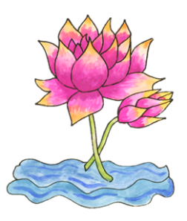  How did Buddha teach his followers to find enlightenment? | 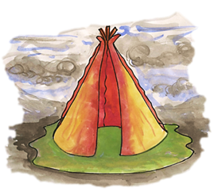  How does the Triple Refuge help Buddhists in their journey through life?

End of phase Buddhism Core knowledge : What do we want pupils to know?
By the end of KS2, pupils learn the story of the Buddha and about his journey to enlightenment including the Four Noble Truths as the essence of Buddhist teaching. Using the correct terminology, pupils are able to explain the key concepts that help Buddhists today on this journey including reference to the Eightfold Path. The role of the Buddhist community is explored as well as the practice of meditation.
Please note: the above will depend on if both Buddhism units are taught in your KS2 scheme of work.

