SCHOOL UNIFORM

Our school uniform is simple, comfortable and affordable. The items with the school crest on it can be ordered through the school, as marked with *. All the other items can be purchased from any retail store.

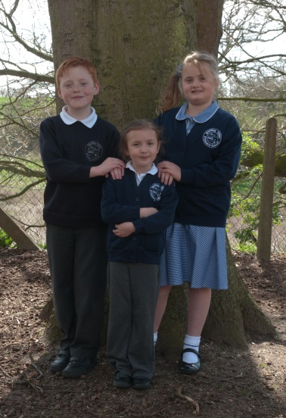

The uniform is as follows:
Bentley Uniform
Grey skirt, pinafore dress, trousers or shorts
White polo-shirt / shirt
Blue checked dress in the summer (optional)
Navy blue sweatshirt or cardigan with
crest*
Navy blue fleece with crest *
Grey tights or black, white or grey socks

Copdock Uniform
Grey skirt, pinafore dress, trousers or shorts
White polo-shirt / shirt
Blue checked dress in the summer (optional)
Royal blue sweatshirt or cardigan with
crest*
Royal blue fleece with crest *
Grey tights or black, white or grey socks

Plain black, durable, flat school shoes. (no trainers, logos, canvas or sandals)
(In extreme weather, boots or wellingtons may be worn to school for use at playtime but shoes must be changed once on site)

Book Bag * to promote independence with the children in bringing in and taking home letters and books.
PE
Black or navy blue shorts
Plain white, round neck t-shirt
Trainers for outdoor use KS1 and KS2
Navy or black jogging bottoms and a sweatshirt are helpful in the colder months.

Drawstring PE bag to keep the kit tidy (this is kept at school during the week).

Children are not permitted to wear jewellery whilst in school, although a watch is acceptable as long as it is removed for PE. Fitbit watches may be allowed dependent on the safety of the activity taking place. If your child has pierced ears, earrings must be plain studs and must be removed for PE and swimming. If your child is unable to remove earrings independently please remove them at home before school on PE days.

We expect all parents who send their children to our school to support the school uniform policy, which is simple and cost effective. Parents should therefore ensure that their child has the correct uniform, and that it is clean and in good repair. We may ask children to remove items which do not meet the above description. The Governing Body will consider, with the headteacher, any requests from parents for individual children to have special dispensations due to a temporary or permanent medical condition.

